📘 SOFTWARE DEVELOPMENT LIFE CYCLE (SDLC)
1. Introduction
The Software Development Life Cycle (SDLC) is a structured process followed by software companies to design, develop, test, deploy, and maintain software systems.
It ensures a systematic approach that improves quality, traceability, and reliability of the final product.
This document explains the SDLC flow as used in real industry environments, including:
- Requirement documentation
- Technical documentation
- Coding
- Testing
- Staging & UAT
- Production release
- Maintenance
A clear and smooth end-to-end project pipeline ensures successful software delivery.
2. SDLC Flow Diagram:
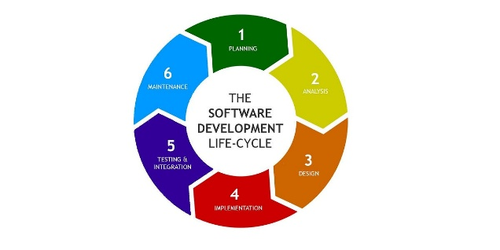
3. Requirement Phase
Requirement Document
- Contains text, wireframes, abstract workflows
- Provided by Product Owner (PO) or Client
- Defines what the system must do
- Includes:
  - User flows
  - Screen wireframes
  - Use cases
  - Scope & constraints
This is the foundation of the entire software project.
4. Technical Documentation Phase
Technical Document
Created by TL (Team Lead) or Architect
Goes through multiple reviews to finalize system structure.
It includes:
- Number of classes
- Interfaces
- Inheritance structure
- System components
- Application modules
- Database design
- API contracts
This stage transforms client requirements into a clear technical blueprint.
5. Coding Phase
Development Begins
Coding work starts after technical document is approved.
- Done by SSE (Senior Software Engineers) and SE (Software Engineers)
- Following coding standards
- Using:
  - Version control (Git)
  - Branching strategies
  - Code reviews
  - Unit test writing
Each module is built and integrated following the architecture.
6. Testing Phase
Testing by QA Team
- Code is deployed on QA Server
- QA performs:
  - Functional testing
  - Smoke testing
  - System testing
  - Security testing
- Bugs are raised and assigned back to developers
- Dev fixes → QA retests → cycle continues
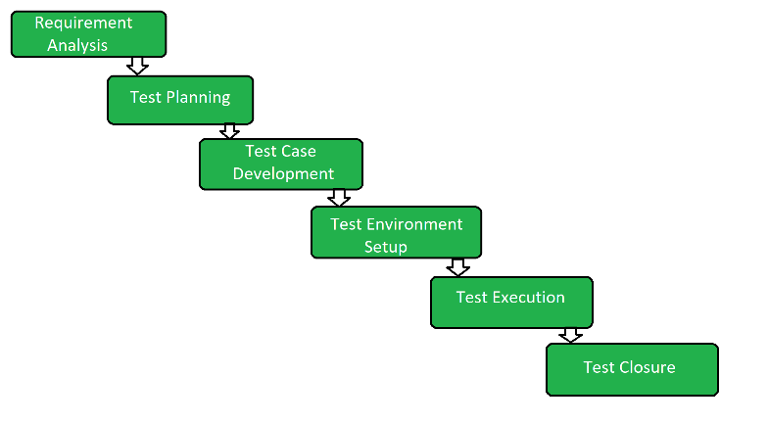
7. Staging & UAT Phase
Staging Environment
Used for advanced testing:
- Regression testing
- Load testing
- Automation test cases execution
UAT (User Acceptance Testing)
- Client tests the application
- Confirms the application works as expected
- After UAT approval → ready for release
8. Pre-Production & Production Phase
PPE – Pre-Production Environment
- Final rehearsal before going live
- Same configuration as Production
- Last sanity check
PE – Production Environment
- Application goes live to real users
- Real-time monitoring starts
- Release notes shared
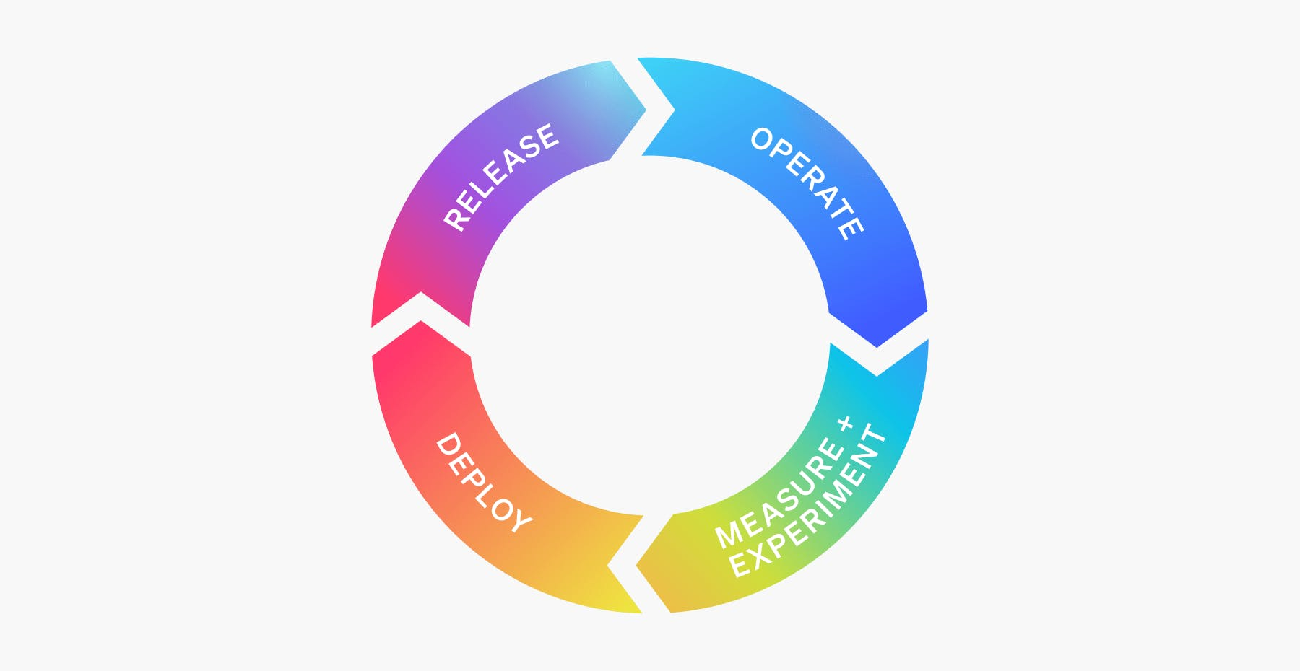
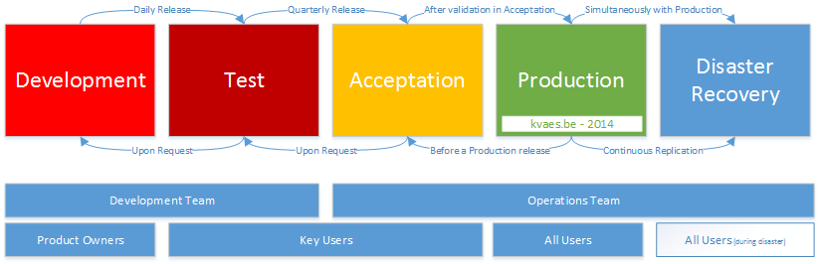
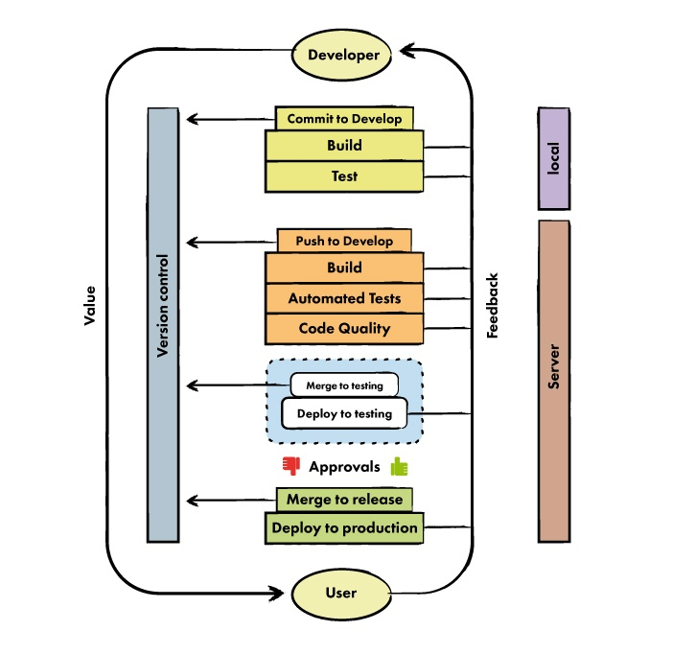
9. Maintenance Phase
Post-Release Activities
- Bug fixing
- Performance improvements
- Patch updates
- Enhancements as per user feedback
This ensures the system stays healthy and updated.
10. Summary (One-Look SDLC Flow)
Requirement → Technical Design → Coding → QA Testing
→ Staging → UAT → Pre-Production → Production → Maintenance

